

EMBEDDED SYTEMS AND SENSOR NETWORS LAB- 3

HEART RATE SENSOR



**SUbMITTED TO:**

**Dr. AHMED RAFAEY HUSSEIN**

**SARA ZIMMO**

**Submitted BY:**

**SHRUTI BAJAJ, 250883615**

**AMANDEEP KAUR MANGAt, 250881486**

**Description:**

This lab teaches to create a heart rate sensor device by measuring an analog signal input on the PSoC 4 BLE device and reporting the measured heart rate value to a BLE enabled device such as an iPhone, in this Lab we have tested using cysmart.

**Objectives:**

1. Measure simulated heart rate using the Programmable Analog Blocks
2. Implement a Heart Rate Profile and send the data over BLE
3. Optimize the design for low power consumption using Sleep, Deep-Sleep and Hibernate modes

|  |  |
| --- | --- |
| **Requirements** | **Details** |
| Hardware | BLE Pioneer Kit (CY8CKIT-042-BLE) |
| 2 jumper wires |
| Software | PSoC Creator 3.1 (or newer) |
| CySmart 1.0 |
| CySmart iOS or CySmart Android Mobile App |

**Block Diagram:**

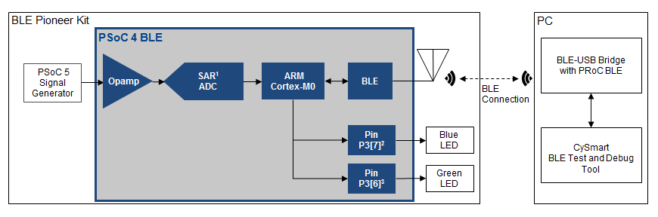

Fig 1. Block Diagram

**Heart Rate Signal**

A representative heart rate electrical signal is shown in Figure 2. Different parts of the signal have different labels. The R peaks represent the time when the heart beats. The heart rate is measured by identifying the time interval between successive R peaks (also known as the RR-interval) and then extrapolating it to the number of RR-intervals over a minute. This gives us the heart rate in beats per minute.

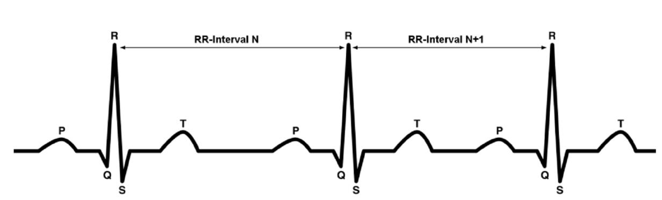

Fig 2. Heart Rate signal graph

**Procedure:**

Started this lab from the template project that is provided.

Configure Schematic:

Open the template project named BLE Lab 3 and follow these steps to get started:

1. Open the schematic by double clicking **TopDesign.cysch** in the Workspace Explorer. There are two sheets in the schematic indicated by tabs at the bottom of the schematic editor.

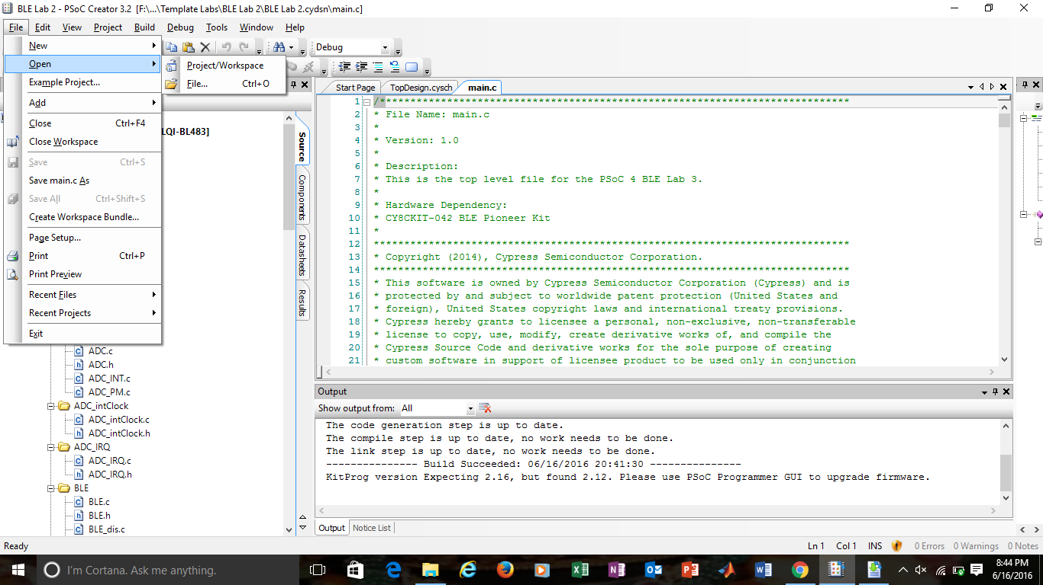

Fig 3. New Project

1. In the Bluetooth Low Energy sheet of the project, place the BLE Component. Double-click it to configure the Component.

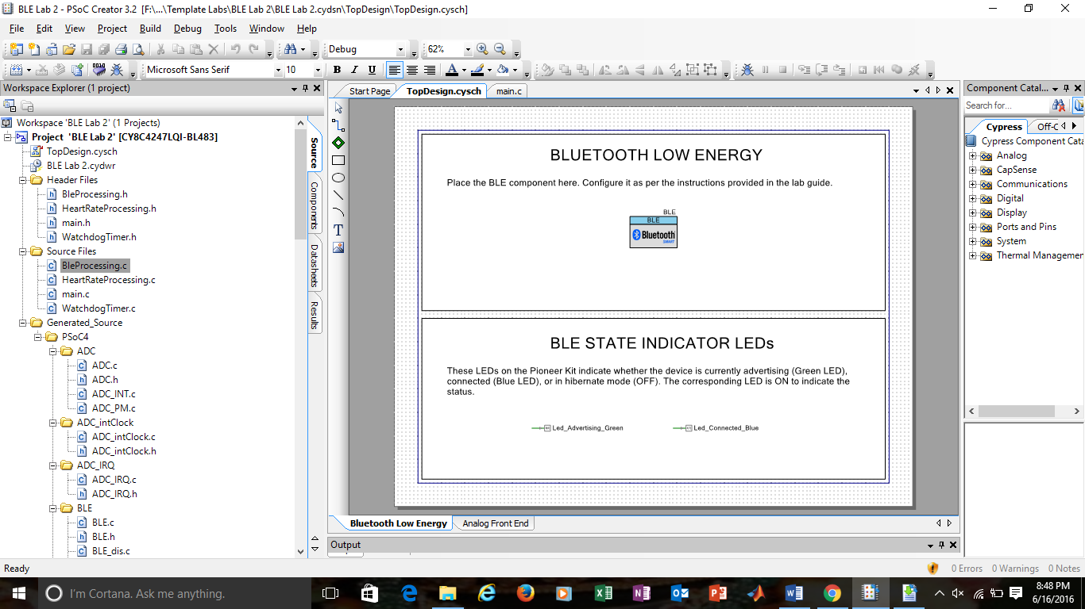

Fig.4 Bluetooth Low Energy & Analog Front sheet

1. General Tab - Set the Profile to Heart Rate and the Profile role to Heart Rate Sensor (GATT Server).

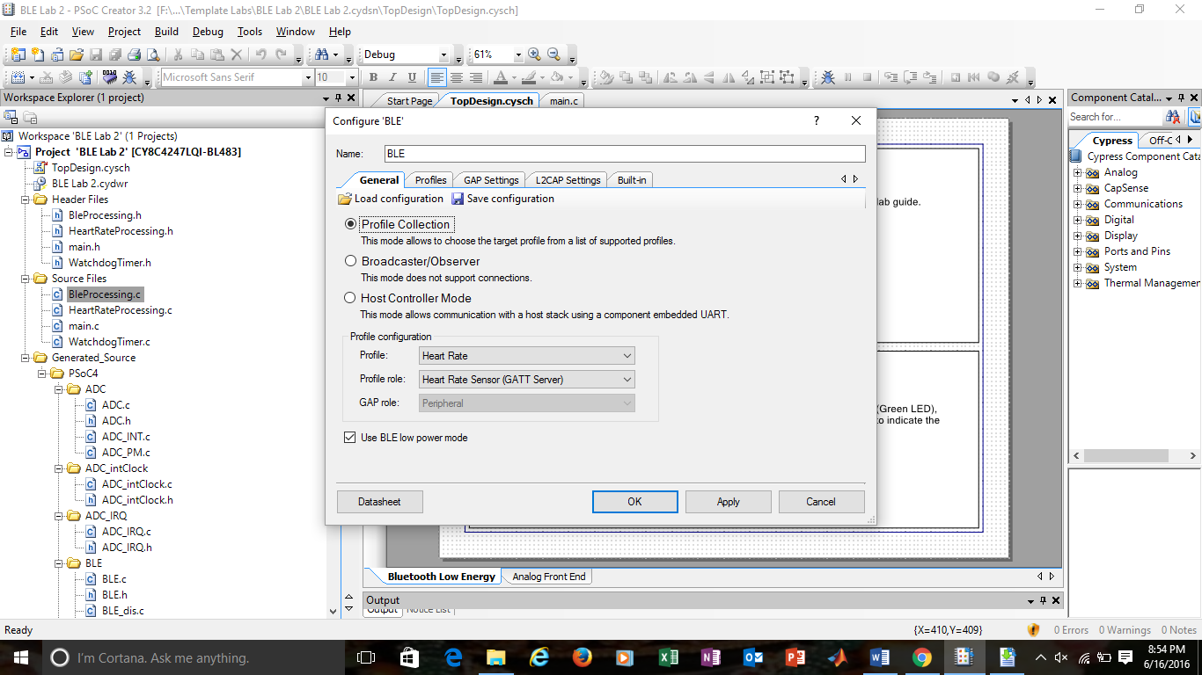

Fig 5. General tab settings

4. Profiles Tab - This tab is automatically populated with the required Services and Characteristics. The Device Information Service (DIS) is a part of the Heart Rate Profile and shows up on the left side. Assign the values to the Characteristics of the DIS as shown in table. These values can be read on the GATT Client BLE device.

|  |  |  |
| --- | --- | --- |
| Characteristic | Field | Value |
| Manufacturer Name String | Manufacturer Name | Cypress Semiconductor |
| Model Number String | Model Number | BLE Pioneer Kit |
| Serial Number String | Serial Number | 1 |
| Hardware Revision String | Hardware Revision | ** |
| Firmware Revision String | FirmwareRevision | 1.0 |

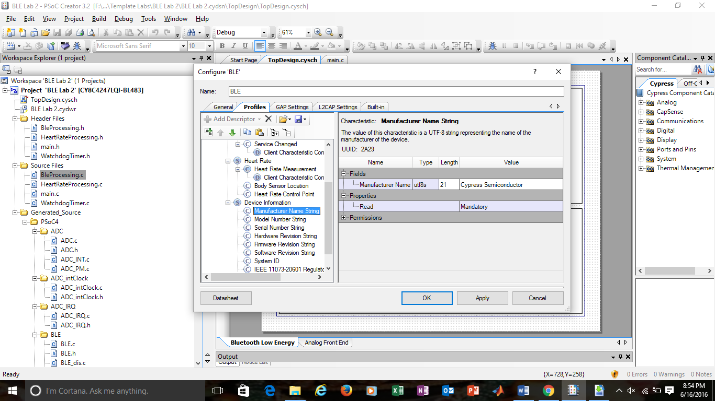

Fig. 6 Profile Settings

5. GAP Settings Tab –

5.1. General

* Set the Device name to Lab-3.
* Set the Maximum Transmission Units MTU (bytes) size to 23.
* Set the TX power level (dBm) to 0.

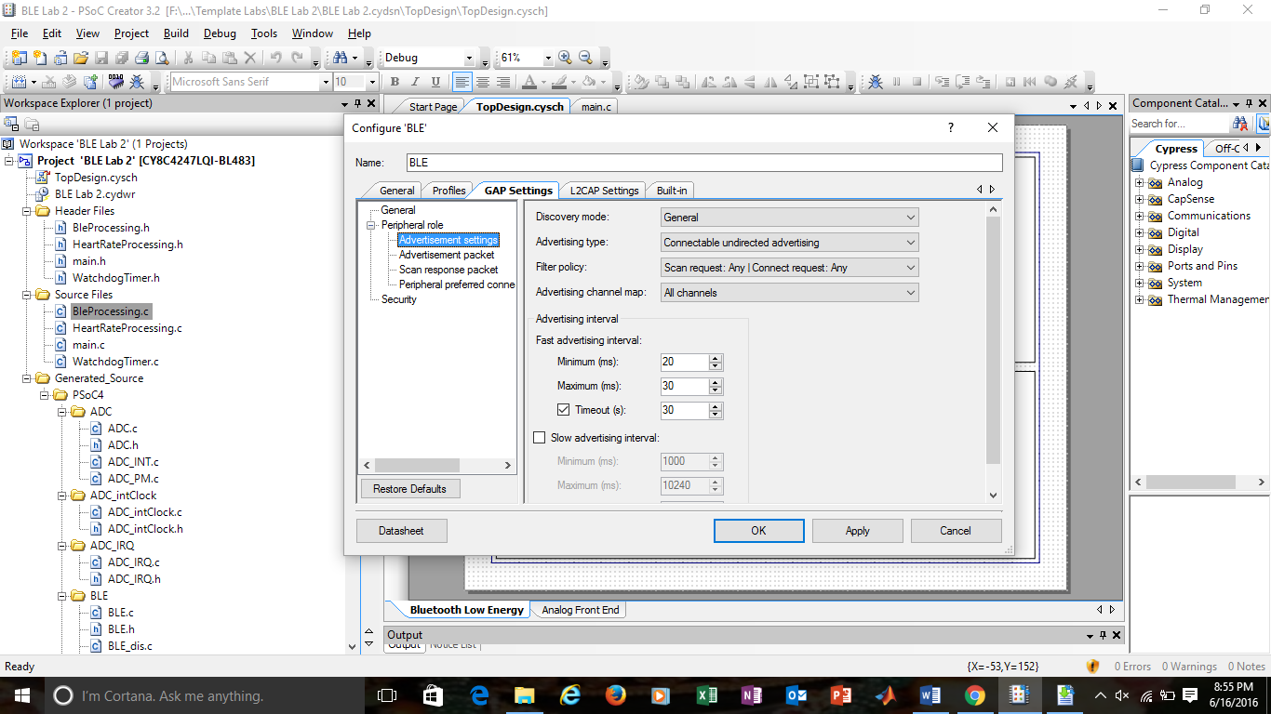

Fig 7. GAP Settings: General

5.2. Peripheral Role ->

* Discovery mode: Select General
* Advertisement type: Select connectable undirected advertising
* Filter policy: Select Scan request: Any | Connect request: Any
* Advertising channel map: Advertise on All channels.
* Fast advertising interval: Select 20 for minimum (ms) and 30 for maximum (ms)  interval. The timeout (s) should be 30.
* Slow advertising interval: Uncheck to disable this setting
* Connection parameters: Leave them at the default values



Fig 8. GAP- Advertisement Settings

5.3. Peripheral Role -> Advertisement Packet details are set as Local name: complete. Checked the Heart rate and Device information under Service UUID.

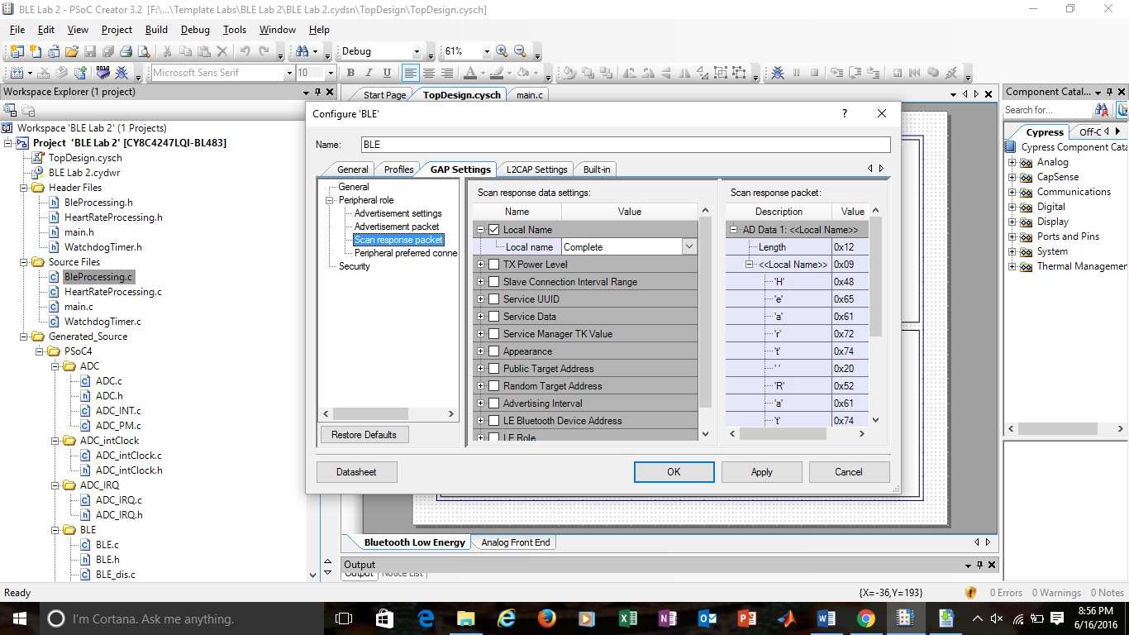

Fig 9. Advertisement Packets

5.4. Peripheral Role -> Scan Response Packet Enable Scan response packet, selected the Local name.



Fig 10. GAP- Scan Response packets

5.5. Security

* Security mode: Select Mode 1 security
* Security level: Select No Security (No Authentication, No Encryption)
* I/O Capabilities: Set this to No Input No Output
* Pairing method: Select Just works
* Bonding requirement: Set this to No Bonding
* Encryption key size (bytes): Left it at the default value of 16

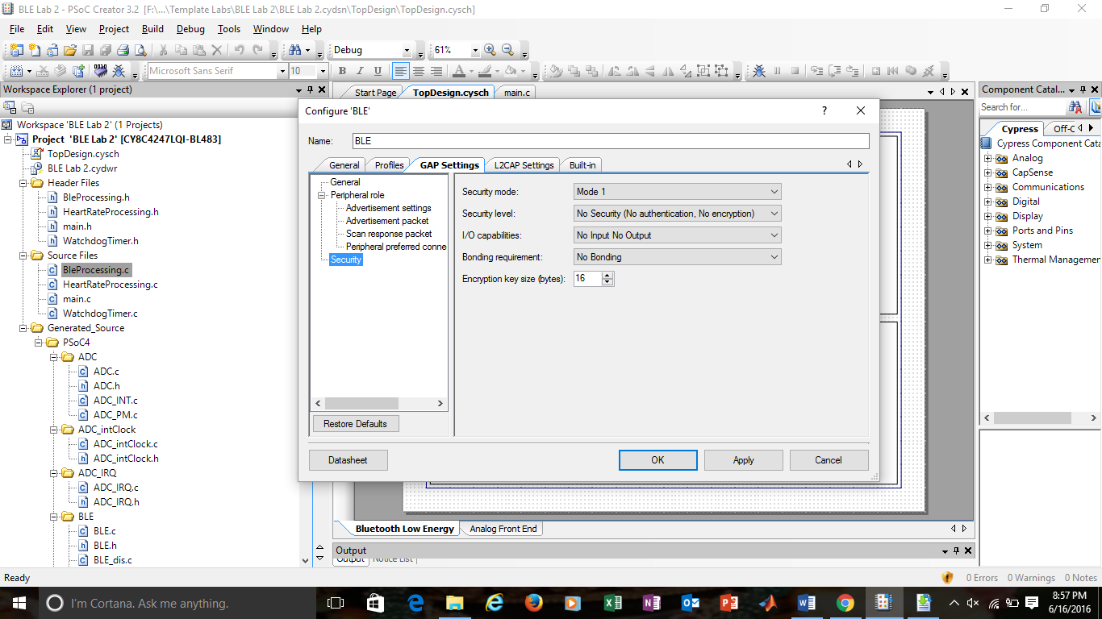

Fig 11. GAP- Security Settings

6. Click OK to close the BLE configuration window.

7. Next, selected the Analog Front End sheet of the project.

8. Drag and drop the Opamp component onto the worksheet.  Double-click it to configure.

9. Named the Component as Opamp and set the Mode to Follower.

10. Click OK to close the configuration window.

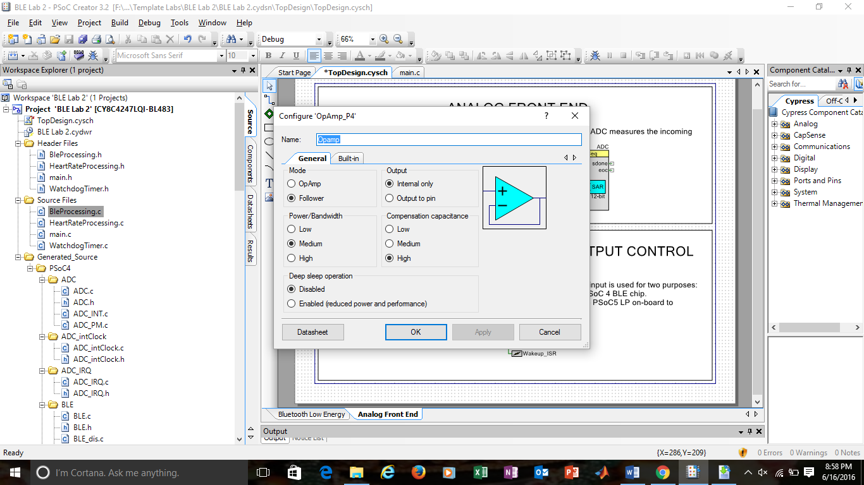

Fig 12. Opamp Configuration

12. Next, searched for the Sequencing SAR ADC Component in the Component Catalog, and dragged and dropped it on the Analog Front End sheet of the schematic. Configure the ADC by double-clicking it.

13.On the General tab of the ADC Component Configuration Tool, set the settings as shown in figure 13. In this figure, set the channel Sample rate to 166666 under timing, Clock source is “**internal**”, sample mode is selected as **hardware trigger**. Under Input range select, Vref select as Internal 1.024 volts, bypassed and Single ended negative input as Vss. Under Result data format, select Different result format as Signed.

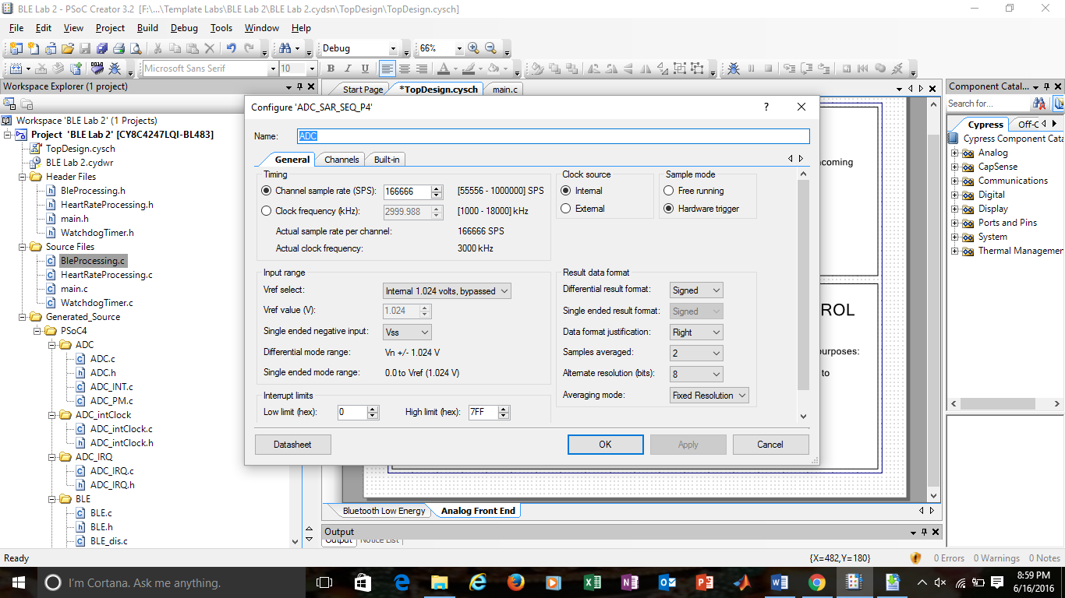

Fig 13. ADC General Settings

1. Configure the settings in the Channels tab as shown in figure 14.Set the sequenced channels as “1” , channel set as zero and Enable has checked. Set the mode to single.

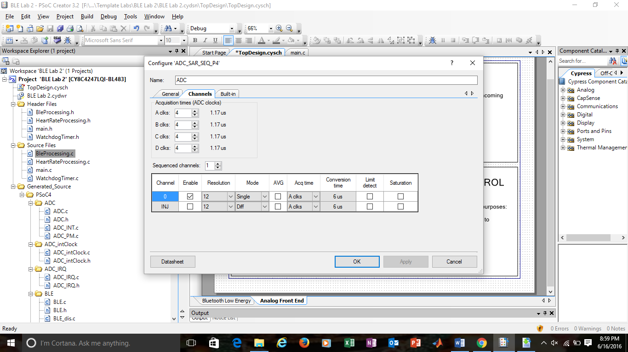

Figure 14. ADC Channel settings

15. Click OK to close the ADC configuration window.

16. On Analog Front End sheet, used the already built-in Logic Low ‘0’ Component and added to the workspace and connected its output to the SOC input of the ADC Component.

17. Connect the Heart_Rate_input pin terminal to the + input of the Opamp.

18. Connect the output of the Opamp to the + input of the ADC. Your schematic sheets should now look like figures 15 shown below.

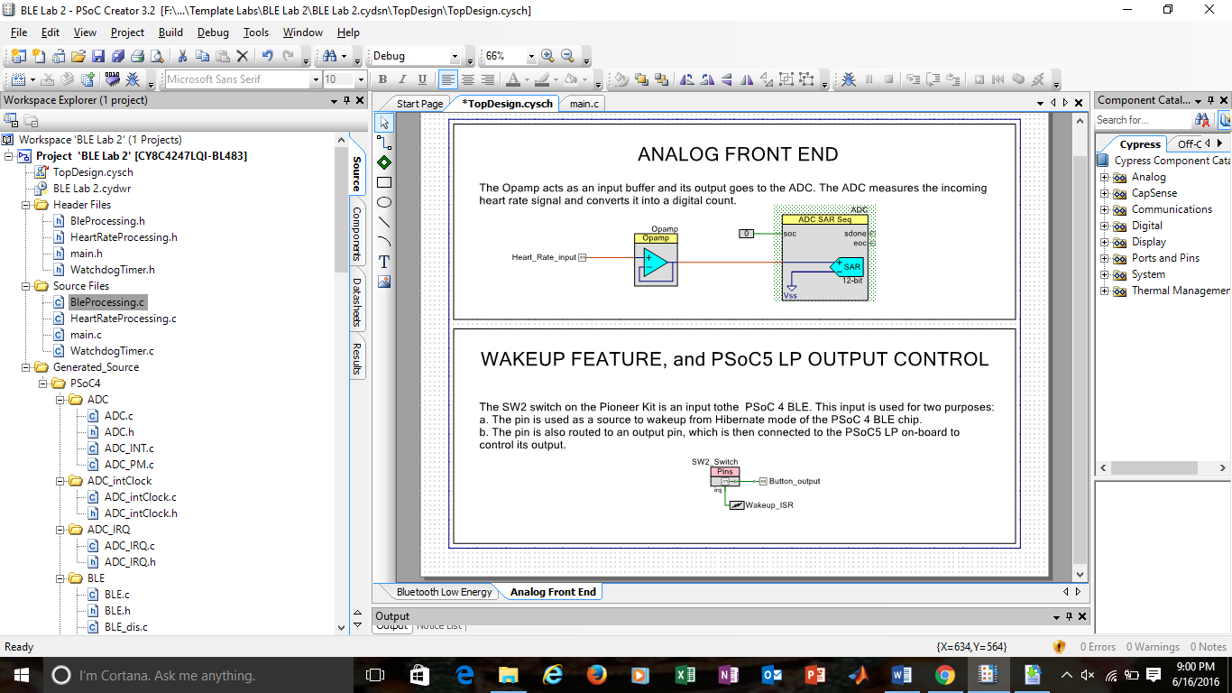

Fig. 15. Analog front End sheet

19. Click the menu item Build -> Build BLE Lab 3 to generate the Component source code files.

20.Build the project to generate the file and program the generate file onto the kit.

**Boot loading PSoC 5**

For bootloading the file, followed the steps as explained below:

1.While pressing the SW1 (Reset) switch, plugged in the kit’s USB connector to the PC. That puts the kit into the bootloader mode.

2. On entry to the bootloader mode, Status LED (LED 2) starts blinking at a frequency of 1 Hz.

3.Launch the Bootloader Host Tool, using Tools -> Bootloader Host.

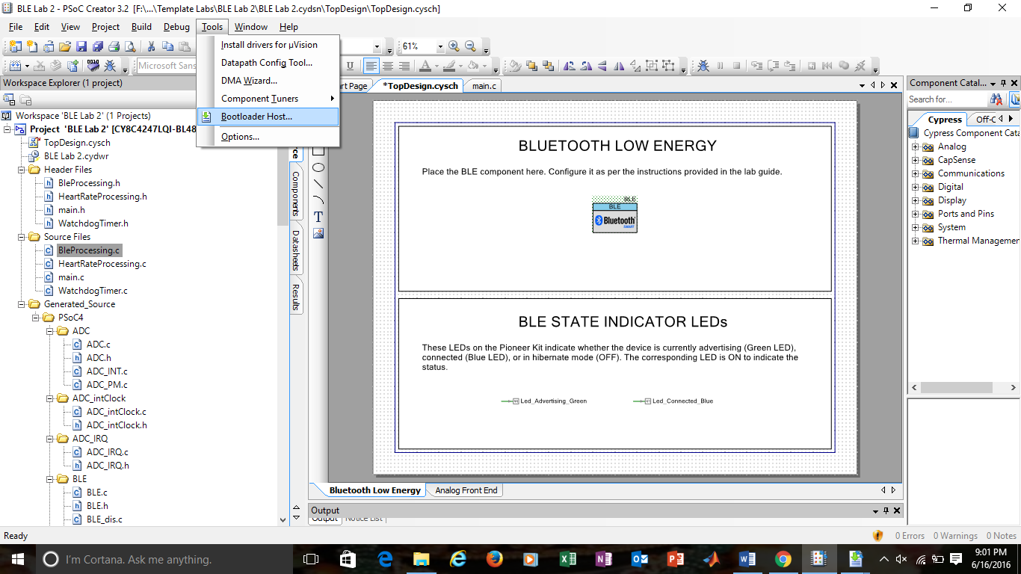

Fig 16Launching Bootloader

4.In the Bootloader Host Tool, click Filters. Check box for Show USB Devices is enabled. Set the VID as 0x04B4, PID as 0xF13B, and click OK.

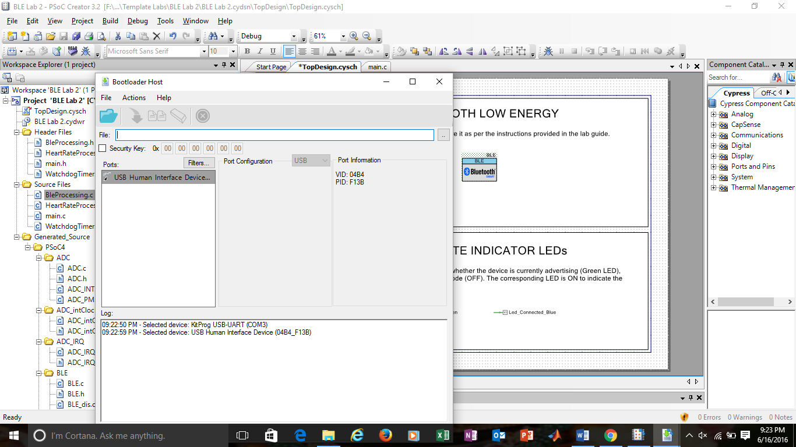

Fig 17. Bootloader- Filter settings

5. Selected the USB Human Interface Device as shown in Figure18.

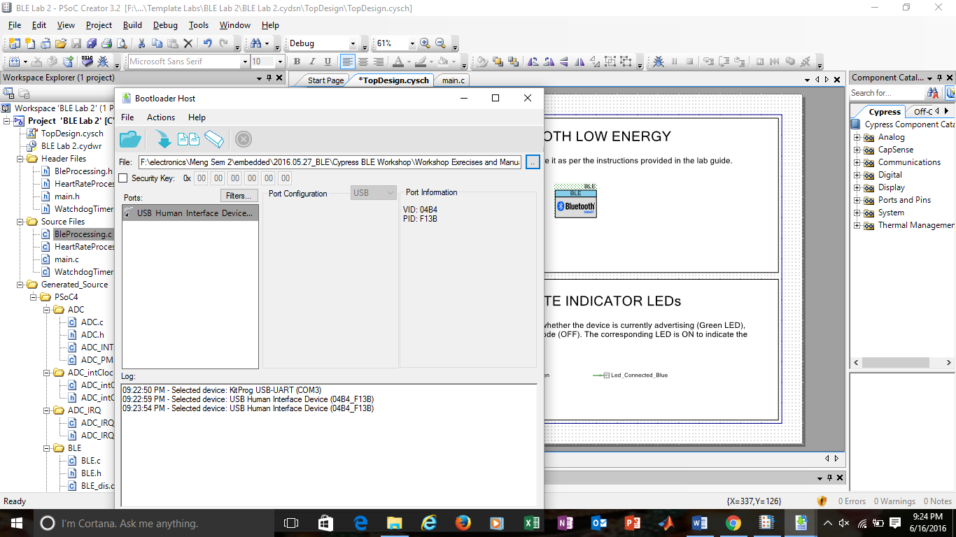

Fig 18. Bootloader- Selecting Human Interface

7. In the Bootloader Host Tool, opened the bootloadable (*.cyacd) file, available in the BLE_Labs then selected the P5LP_KitProg_Custom folder. I did this by using File > Open > kitProg_folder.

8.Programmed the PSoC 5 on the kit by selecting , Actions > Program menu item.

9.After the programming is complete, the log window displays Programming Finished Successfully.

**Testing:**

For testing the program followed these steps:

1.PSoC 5 generates the heart rate signal on P0.0, with an expected value of around 115. Connect this pin (Pin 3 on J8) to P2.0 of PSoC 4 BLE (Pin 2 on J2).

2.The generated heart rate signal can be changed to reflect different heart rate values within a range of 60 – 115 bpm. To check the different values, we will use the SW2 switch on the kit. For this purpose, connect the PSoC 5 pin P3.4 (Pin 5 on J8) to pin P3.0 of PSoC 4 BLE (Pin 1 on J2).

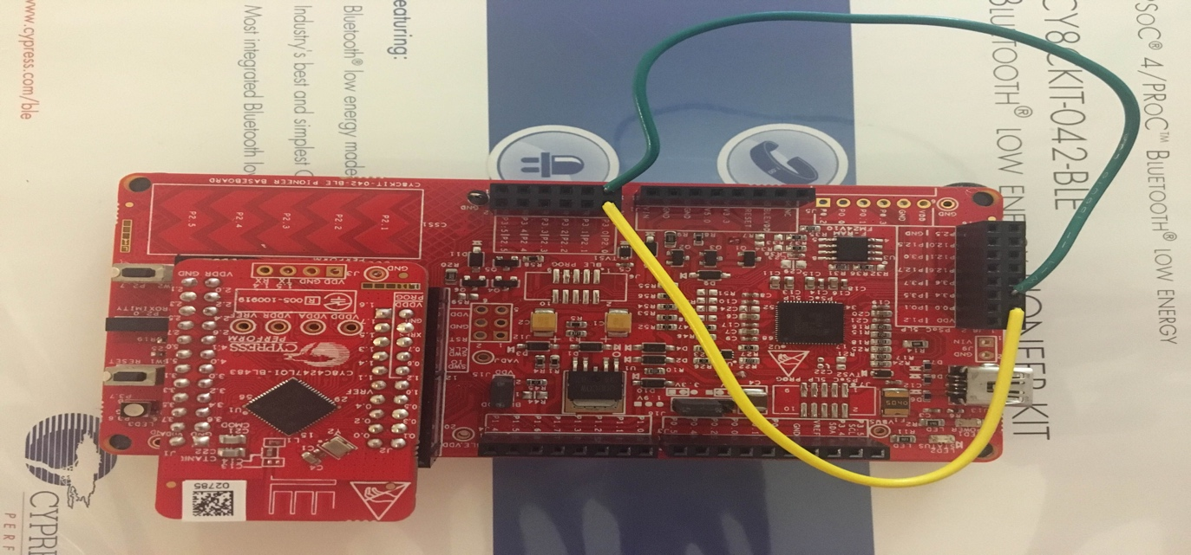

Fig. 19. Pin Connections for the Kit

3.Open CySmart 1.0 and connected the BLE-USB Bridge to it. The USB will start scanning and it will stop once it finds the device. Connect the device: Select the appropriate device name in this case “Heart Rate sensor” and click Connect.

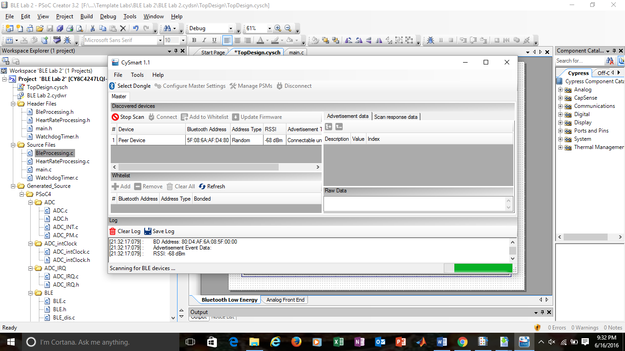

Fig 20. CySmart Launch

4.Upon connection, a new tab opens in the tool. Select Discover All Attributes to list all the Services,  Characteristics and Descriptors of the device.

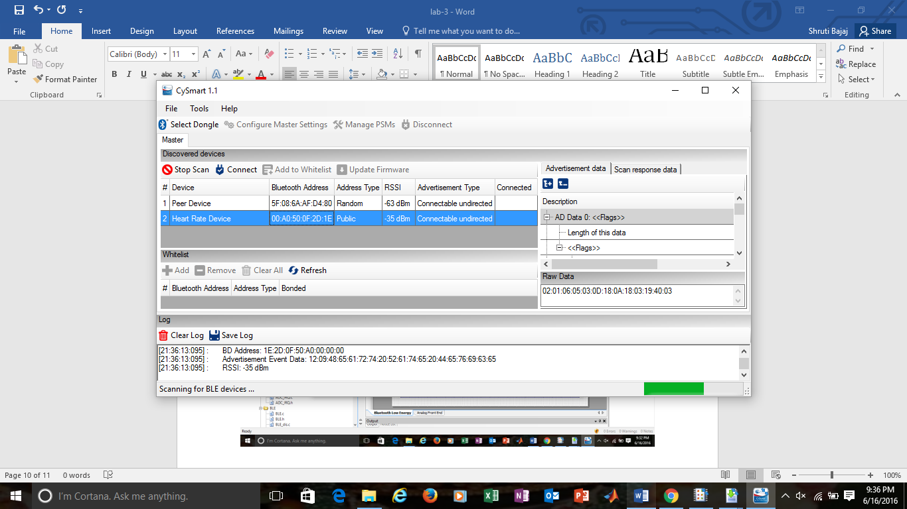

Fig.21 CySmart- Select Discover all atrributes

5.Click Enable All Notifications on the top to enable Heart Rate Measurement Characteristic notifications.

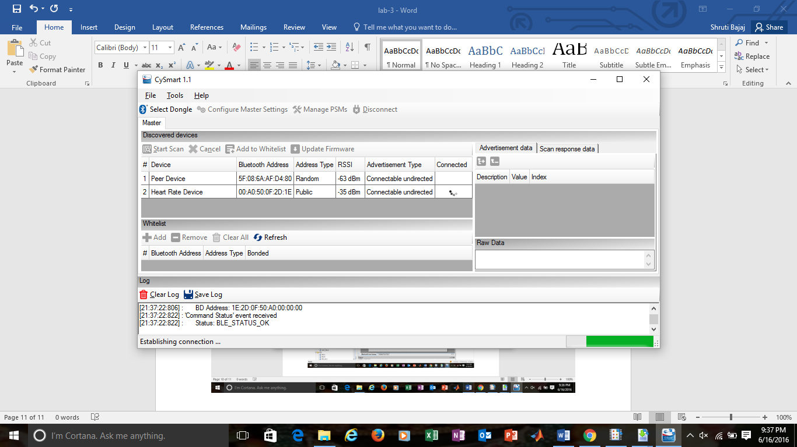

Fig 22. Enabling Heart Rate Notifications

6.The values of of the Heart Rate Measurement Characteristic is updated every second. When we press the SW2 switch on the kit and observe, the heart rate number changes as it records the heart rate. A few different picture of heart rate changes are as below.

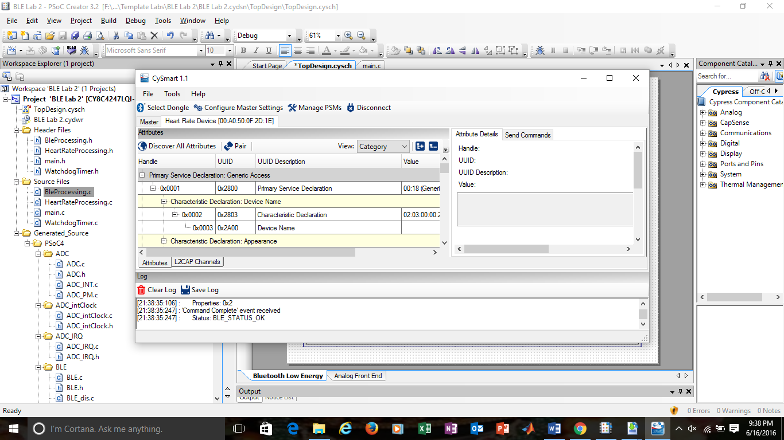

Fig. 23 Heart arte measurement

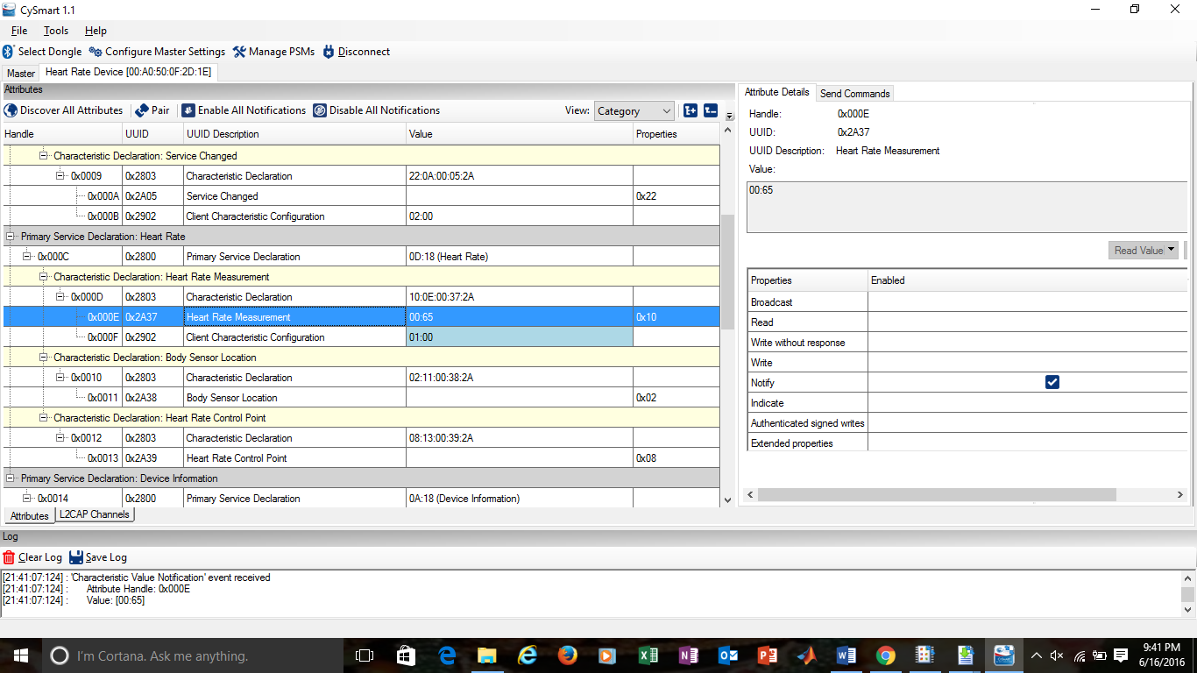

Fig. 24 Heart rate Change

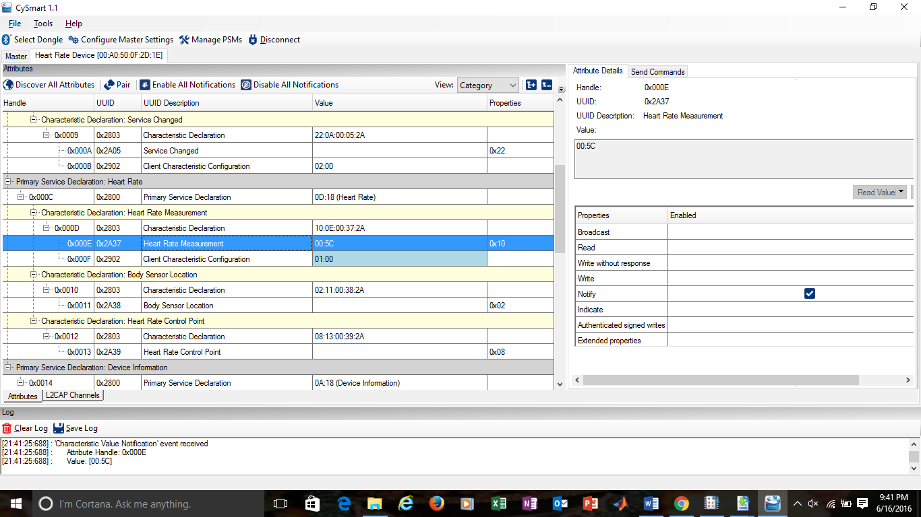

Fig. 25. Heart Rate change

8.Disconnect the device and notice that the RGB LED turns off. At this point, the device has entered the  Hibernate mode.  Press the SW2 switch now to see that the Green LED turns on and the device starts advertising again.